- Program ID : VA005MA1

- Display Layout
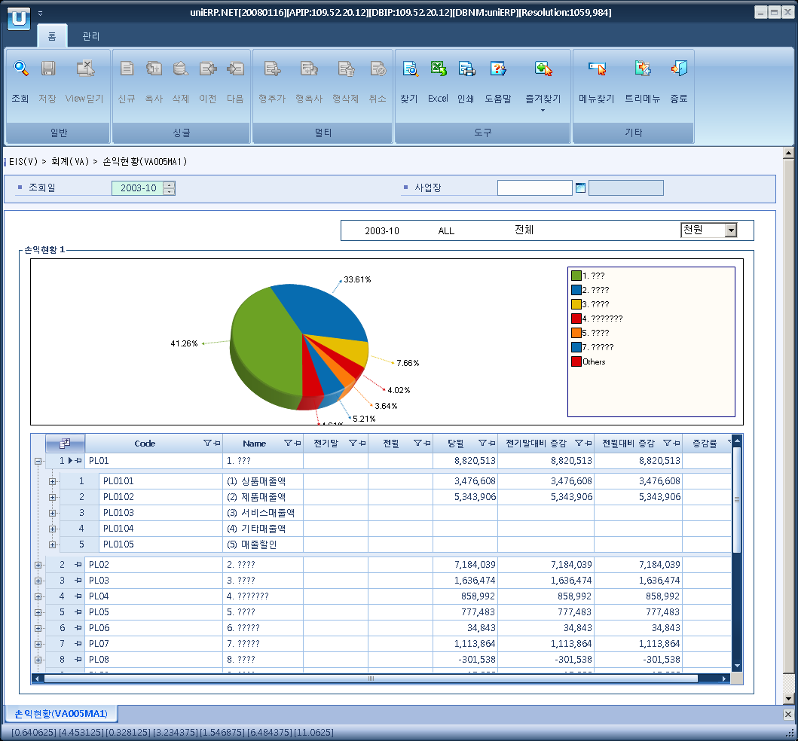

- Event flow
- Click Query button
- OnFncQuery -> DbQuery -> DataChange
- Display Unit combo change
- uniCombo1_ValueChanged -> DataChange

- SQL Statements
- Profit and Loss
WITH BSHire(lvl_cd1, lvl_nm1, lvl_cd2, lvl_nm2, lvl_cd3, lvl_nm3, lvl_cd4, lvl_nm4,
lvl_cd5, lvl_nm5, lvl_cd6, lvl_nm6, lvl_cd7, lvl_nm7, lvl_cd8, lvl_nm8,
bal_fg, class_lvl, class_seq, class_cd, class_nm, group_cd, acct_cd, sort)
AS (SELECT class_cd, class_nm,
CONVERT(VARCHAR(20), NULL), CONVERT(VARCHAR(50), NULL), CONVERT(VARCHAR(20), NULL), CONVERT(VARCHAR(50), NULL),
CONVERT(VARCHAR(20), NULL), CONVERT(VARCHAR(50), NULL), CONVERT(VARCHAR(20), NULL), CONVERT(VARCHAR(50), NULL),
CONVERT(VARCHAR(20), NULL), CONVERT(VARCHAR(50), NULL), CONVERT(VARCHAR(20), NULL), CONVERT(VARCHAR(50), NULL),
CONVERT(VARCHAR(20), NULL), CONVERT(VARCHAR(50), NULL),
bal_fg, class_lvl, class_seq, class_cd, class_nm,
class_cd AS group_cd, CONVERT(VARCHAR(20), '*') AS acct_cd,
CONVERT(varchar(255), CONVERT(varchar(5), class_lvl) + REPLICATE('0', 3 - DATALENGTH(CONVERT(varchar(5), class_seq))) + CONVERT(varchar(5), class_seq))
FROM a_acct_class
WHERE class_type = 'PL'
AND class_lvl = 1
UNION ALL
SELECT a.lvl_cd1, a.lvl_nm1,
CASE a.class_lvl + 1 WHEN 2 THEN b.class_cd ELSE a.lvl_cd2 END,
CASE a.class_lvl + 1 WHEN 2 THEN b.class_nm ELSE a.lvl_nm2 END,
CASE a.class_lvl + 1 WHEN 3 THEN b.class_cd ELSE a.lvl_cd3 END,
CASE a.class_lvl + 1 WHEN 3 THEN b.class_nm ELSE a.lvl_nm3 END,
CASE a.class_lvl + 1 WHEN 4 THEN b.class_cd ELSE a.lvl_cd4 END,
CASE a.class_lvl + 1 WHEN 4 THEN b.class_nm ELSE a.lvl_nm4 END,
CASE a.class_lvl + 1 WHEN 5 THEN b.class_cd ELSE a.lvl_cd5 END,
CASE a.class_lvl + 1 WHEN 5 THEN b.class_nm ELSE a.lvl_nm5 END,
CASE a.class_lvl + 1 WHEN 6 THEN b.class_cd ELSE a.lvl_cd6 END,
CASE a.class_lvl + 1 WHEN 6 THEN b.class_nm ELSE a.lvl_nm6 END,
CASE a.class_lvl + 1 WHEN 7 THEN b.class_cd ELSE a.lvl_cd7 END,
CASE a.class_lvl + 1 WHEN 7 THEN b.class_nm ELSE a.lvl_nm7 END,
CASE a.class_lvl + 1 WHEN 8 THEN b.class_cd ELSE a.lvl_cd8 END,
CASE a.class_lvl + 1 WHEN 8 THEN b.class_nm ELSE a.lvl_nm8 END,
ISNULL(b.bal_fg, a.bal_fg), CONVERT(smallint, a.class_lvl + 1),
b.class_seq, b.class_cd, b.class_nm,
CASE WHEN b.class_cd = b.acct_cd THEN a.class_cd ELSE b.class_cd END AS group_cd,
CASE WHEN b.class_cd = b.acct_cd THEN b.acct_cd ELSE '*' END AS acct_cd,
CONVERT(VARCHAR(255), RTRIM(Sort) + '|' + CONVERT(VARCHAR(5), a.class_lvl + 1) + REPLICATE('0', 3 - DATALENGTH(CONVERT(varchar(5), ISNULL(b.class_seq, a.class_seq)))) + CONVERT(varchar(5), ISNULL(b.class_seq, a.class_seq)))
FROM BSHire AS a
JOIN (SELECT par_class_cd, class_cd, class_nm, class_seq, bal_fg, '*' AS acct_cd
FROM a_acct_class
WHERE class_type = 'PL'
AND class_lvl > 1
AND class_cd <> par_class_cd
UNION ALL
SELECT a.class_cd AS par_class_cd, a.acct_cd AS class_cd,
b.acct_nm AS class_nm, NULL AS class_seq, NULL, a.acct_cd
FROM a_clssfc_of_acct a
INNER JOIN a_acct b
ON b.acct_cd = a.acct_cd
WHERE a.class_type = 'PL') AS b
ON a.class_cd = b.par_class_cd )
SELECT a.lvl_cd1 + '|' + a.lvl_nm1 AS lvl1,
a.lvl_cd2 + '|' + a.lvl_nm2 AS lvl2,
a.lvl_cd3 + '|' + a.lvl_nm3 AS lvl3,
a.lvl_cd4 + '|' + a.lvl_nm4 AS lvl4,
a.lvl_cd5 + '|' + a.lvl_nm5 AS lvl5,
CASE WHEN a.lvl_cd2 + '|' + a.lvl_nm2 IS NULL THEN 1
ELSE CASE WHEN a.lvl_cd3 + '|' + a.lvl_nm3 IS NULL THEN 2
ELSE CASE WHEN a.lvl_cd4 + '|' + a.lvl_nm4 IS NULL THEN 3
ELSE CASE WHEN a.lvl_cd5 + '|' + a.lvl_nm5 IS NULL THEN 4
ELSE 5
END
END
END
END AS lvl,
ISNULL(SUM(b.amt1), 0) AS amt1,
ISNULL(SUM(b.amt2), 0) AS amt2,
ISNULL(SUM(b.amt3), 0) AS amt3,
ISNULL(SUM(b.amt3), 0) - ISNULL(SUM(b.amt1), 0) AS amt4,
ISNULL(SUM(b.amt3), 0) - ISNULL(SUM(b.amt2), 0) AS amt5,
CASE WHEN ISNULL(SUM(b.amt2), 0) = 0 THEN 0
ELSE (ISNULL(SUM(b.amt3), 0) - ISNULL(SUM(b.amt2), 0)) /
ISNULL(SUM(b.amt2), 0) * 100
END AS amt6,
MIN(a.sort) AS sort
FROM BSHire a
LEFT MERGE JOIN (SELECT bs_pl_flag, acct_cd, SUM(loc_amt1) AS amt1, SUM(loc_amt2) AS amt2, SUM(loc_amt3) AS amt3
FROM (SELECT bs_pl_flag, acct_cd, ISNULL(bs_pl_amt, 0) AS loc_amt1, NULL AS loc_amt2, NULL AS loc_amt3
FROM vb000bt
WHERE yyyymm = (@strYear - 1) + '12'
AND biz_area_cd = @strBizArea
AND class_type = 'PL'
UNION ALL
SELECT bs_pl_flag, acct_cd, NULL, ISNULL(bs_pl_amt, 0), NULL
FROM vb000bt
WHERE yyyymm = CONVERT(VARCHAR(6), DATEADD(MONTH, -1, @strYear + @strMonth + '01'), 112)
AND biz_area_cd = @strBizArea
AND class_type = 'PL'
UNION ALL
SELECT bs_pl_flag, acct_cd, NULL, NULL, ISNULL(bs_pl_amt, 0)
FROM vb000bt
WHERE yyyymm = @strYear + @strMonth
AND biz_area_cd = @strBizArea
AND class_type = 'PL') a
GROUP BY bs_pl_flag, acct_cd) b
ON b.bs_pl_flag = a.group_cd
AND b.acct_cd = a.acct_cd
GROUP BY a.lvl_cd1 + '|' + a.lvl_nm1, a.lvl_cd2 + '|' + a.lvl_nm2,
a.lvl_cd3 + '|' + a.lvl_nm3, a.lvl_cd4 + '|' + a.lvl_nm4,
a.lvl_cd5 + '|' + a.lvl_nm5
HAVING a.lvl_cd1 + '|' + a.lvl_nm1 IS NOT NULL
ORDER BY sort, a.lvl_cd1 + '|' + a.lvl_nm1, a.lvl_cd2 + '|' + a.lvl_nm2,
a.lvl_cd3 + '|' + a.lvl_nm3, a.lvl_cd4 + '|' + a.lvl_nm4,
a.lvl_cd5 + '|' + a.lvl_nm5

